**Market study to determine feasibility of starting a one stop discount auto shop in the Etobicoke borough of Toronto**

# Introduction

# Canada is an auto nation. Residents of Toronto and its suburbs depend heavily on automobiles (cars, vans, SUVs and trucks) for travel and transportation. This leads to wear and tear of the automobiles and their tires. It makes business sense to start a one stop franchise that provides the following auto services and commodities at a discounted rate.

* + Oil change, servicing and repairs
  + Tires replacement
  + Auto body shop

This presentation is targeted towards those business executives in the automobile servicing industry who are looking to expand their franchise operations in Toronto and its suburbs

Data that might contribute to determining a go/no go decision might include existing auto shops

within a 5 km radius, services offered and frequency of customer visits.

This project aims to understand feasibility of starting a one stop auto shop franchise in the Etobicoke suburbs of Toronto

# Data acquisition and cleaning

* The neighborhood data was scraped from the Wikipedia web page

<https://en.wikipedia.org/wiki/List_of_postal_codes_of_Canada:_M>

* This data was supplemented with geographical data downloaded from

<https://cocl.us/Geospatial_data>

* Data downloaded or scraped from the above sources was combined
* Unassigned boroughs were dropped
* Unnamed neighborhoods in a borough were updated with the respective borough name
* Venues grouped by category per neighborhood were retrieved using the FourSquare GET request url
* Only data for the Etobicoke was used since this was the target market
* Target radius was 5 km
* The top 10 common categories that were frequently used and visited by customers were identified

# Exploratory Analysis

Initial review and analysis of the below result set determined that there were no auto shops within a 5km radius of the Etobicoke neighborhoods

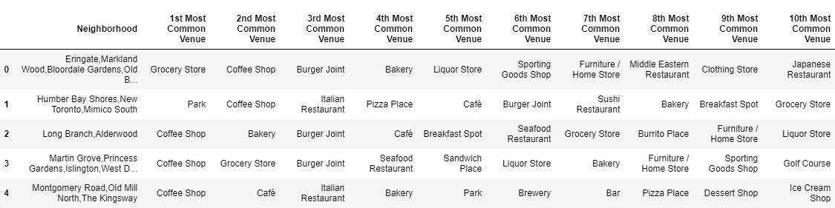

## Clustering models

To further support the initial findings KMeans clustering with a sample set of 5 was used.

Results below

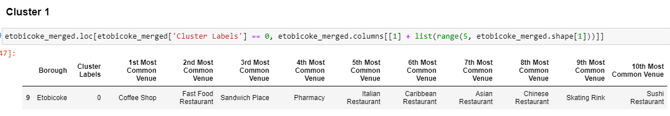

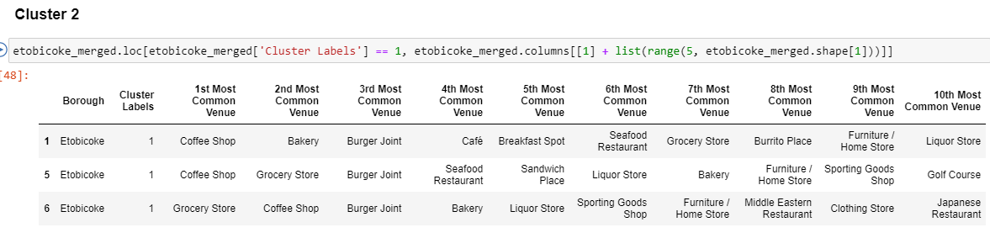

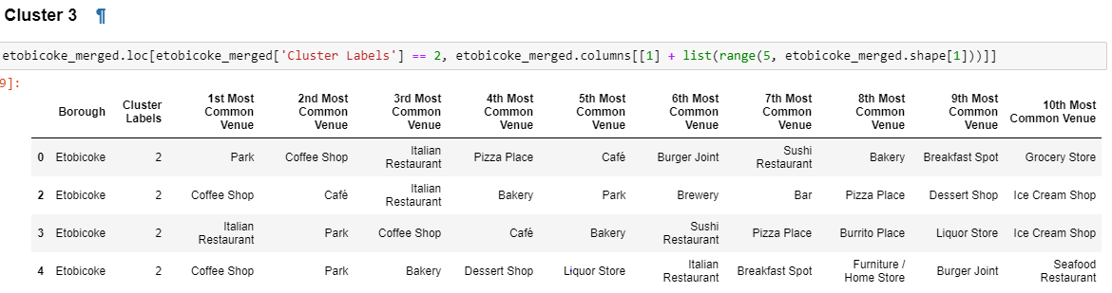

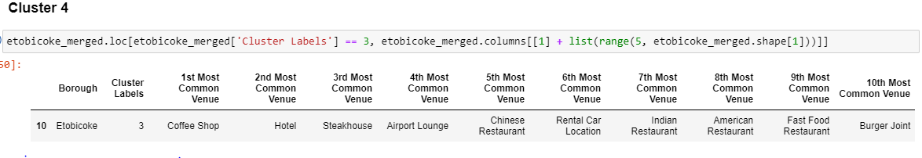

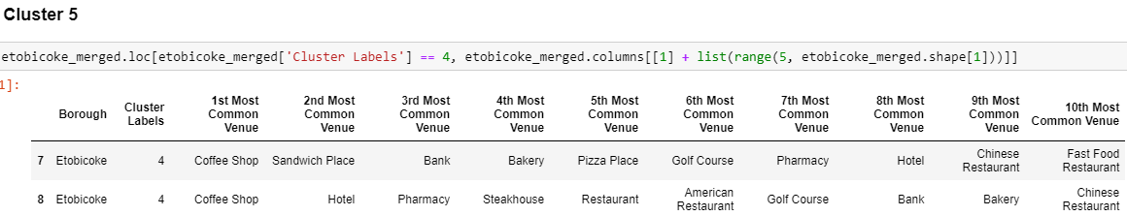

# Conclusion and future directions

Based on the data analysis, review and models built it is feasible to start a one stop shop Auto franchise in the Etobicoke market, to provides the following services to automobile owners and users

Oil change, servicing and repairs

Tires replacement

Auto body shop

Next up are

Analyze automobile ownership data

Analyze pricing model